**Challenge d**

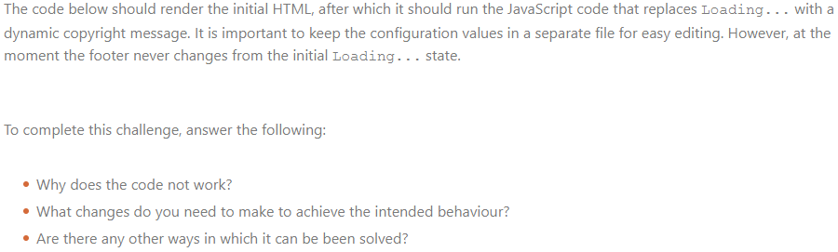

// configuration.js

const company = 'ACME Inc.'

const year = 2022

________________________________________________________________________________________

// scripts.js

import company form 'configuration'

import year form 'configuration'

const message = '© ' + company + ' (' + year + ')'

document.querySelector('footer').innerText = message  
  
________________________________________________________________________________________  
  
<!-- index.html -->

<html>

<head>

<scripts scr="./scripts">

</head>

<body>

<h1>Welcome</h1>

<p>This is our website</p>

</body>

<footer>Loading...</footer>

</html>

**Challenge e**

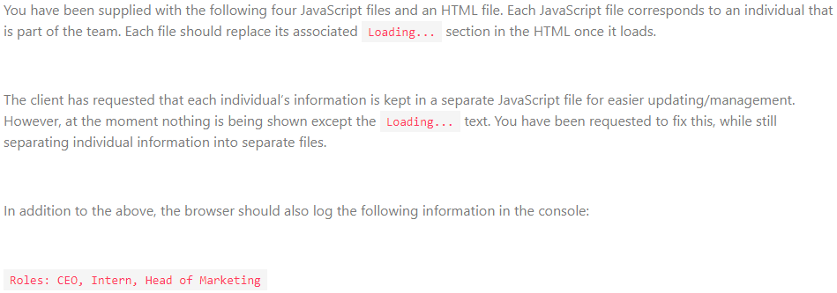

// nwabisa.js

private firstname = "Nwabisa"

private surname = "Gabe"

public role = "CEO"

private display= firstname + " " + surname + " (" + role + ")"

document.querySelector('#nwabisa').innerText = display

_________________________________________________________________________________________  
  
// johannes.js

private firstname = "Johannes"

private surname = "Potgieter"

public role = "Intern"

private display= firstname + " " + surname + " (" + role + ")"

document.querySelector('#johannes').innerText = display

_________________________________________________________________________________________  
  
// alex.js

private firstname = "Alex"

private surname = "Naidoo"

public role = "Head of Marketing"

private display= firstname + " " + surname + " (" + role + ")"

document.querySelector('#alex').innerText = display

_________________________________________________________________________________________  
  
// scripts.js

console.log('Roles:', nwabisa.role, johanes.role, alex.role)

_________________________________________________________________________________________  
  
<!-- index.html -->

<html>

<script module="nwabisa">

<script module="johannes">

<script module="alex">

<script nomodule="scripts">

<body>

<h1>Our Team</h1>

<ul>

<li id="nwabisa">Loading...</li>

<li id="johannes">Loading...</li>

<li id="alex">Loading...</li>

</ul>

</body>

</html>